User Wait Time Testing on SRW

To gather information that would help optimize the web interface of SRW, to resolve the issue of excessively long wait times for executions of simulations via web, tests were carried out and data was collected regarding the differences between the times of execution via web interface and executions via command line interface, as well as the distribution of total user wait time between different processes, such as calculation, data transfer. Differences in the efficiencies of the three servers running SRW were tested as well. It was discovered that, for nearly all tested simulations, the user wait time on the web interface was higher than the wait time for an identical simulation carried out via command line interface, with some simulations taking six times longer on the web than on the command line interface. It was determined that often the excessive wait time on the web was a result of excessive time being spend on data transfer, with data transfer making up from a quarter up to a half of total user wait time.

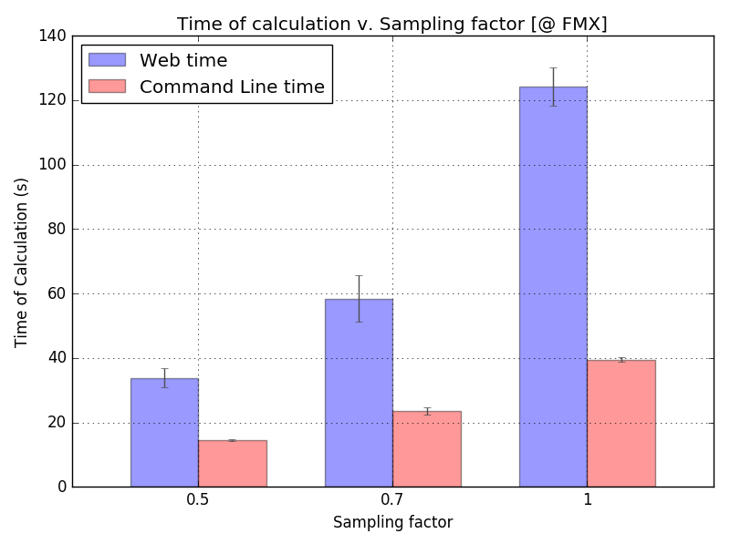At the start of the investigation, total user wait times for executions of simulations were measured on the web interface and the command line interface, to see how different the wait times were on the two interfaces. The wait times were measured for executions of identical simulations at varying parameters of resolution, to see whether those parameters affected web and command line wait times differently. The tests have shown that, with the increase in resolution, the web interface lagged more and more significantly behind the command line interface. This suggested that the reason why the web was often slower than command line was the amount of data transfer that the web interface needed to do: with the increase in resolution, the amount of calculation that is required should reasonably increase by equal factors regardless of what interface you use; the web application, though, transfers all of the resulting data to the client (to allow user to zoom into reports, to see detailed reports), constituting a large amount of data transfer; at the same time, when using the command line interface, the result data is visualized on server, and only a small graphic file needs to be transferred to client. With the increase in resolution, more and more data needs to be transferred from server to client when using the web interface, making the web wait time longer and longer. The plot below illustrates some of the data that was collected.

Note: the tests were done on an FMX simulation that uses thin lens element (horizontal focal length = 9.92727 m) to simulate HFM, while the current version uses a spherical mirror element.

To determine whether there were significant differences in the amount of time spent by SRW on actual simulation calculations depending on whether it was accessed via web or command line interfaces, a feature was implemented in the web interface that provided a value called “duration” that indicated the time spent only on calculation for every simulation done via web interface. The duration values of calculations done on the web were compared with wait times for identical calculations performed via command line, which allowed us to prove that the amounts of time spent on actual calculations were not significantly different for calculation performed via the web or the command line interfaces. The calculations were also performed at various resolution settings. The calculation time averages for the web and the command line interfaces were very close at both high and low resolutions, as you can see from the table below. This strengthened our assurance in that the excessive wait times in the web interface were due to large amounts of data transfer, not differences in calculation time.

|  |  |
| --- | --- |
| Sampling factor | Average [Web]:[Command Line] Calculation Time Ratio |
| 0.3 | 0.908 |
| 0.7 | 1.096 |
| 1.0 | 1.218 |

To find out just how seriously the data transfer time affected performance of the web interface, we compared the values of duration (calculation time) and total user wait time on web interfaces of three servers running SRW. Ratios of Data Transfer Time to Total Wait Time were calculated to determine what fraction of total wait time was spent on data transfer. From these ratios, we could see that the data transfer took from a quarter up to a half of total user wait time. The charts below illustrate some of the data that was collected. 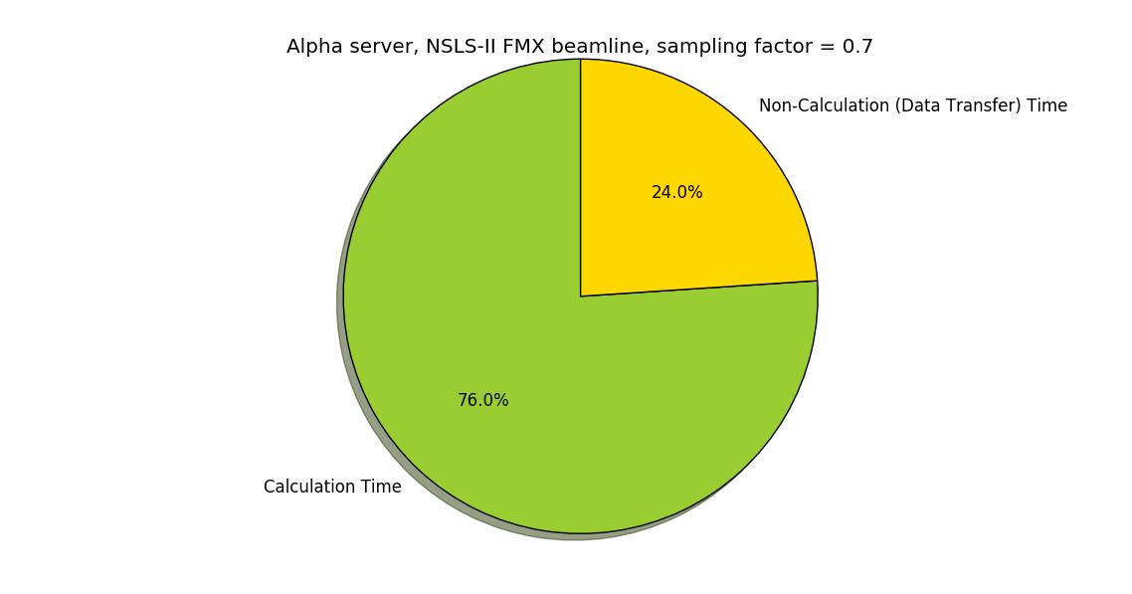

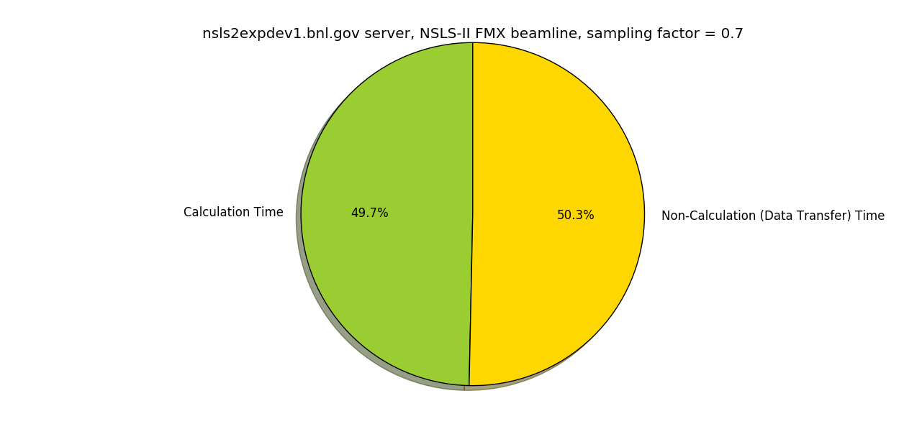

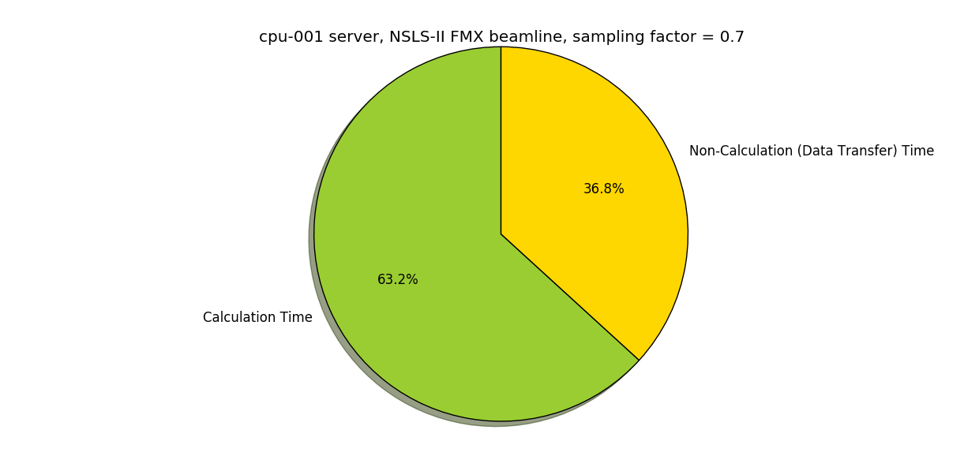

The fact that, in the web interface, from a quarter to a half of user wait time was spent on data transfer indicated to us that, to optimize web interface performance, the amount of data transferred must be optimized.

To gather some additional information, the efficiency of the web interface on the three servers running SRW was compared. The plot below illustrates how the servers compare.

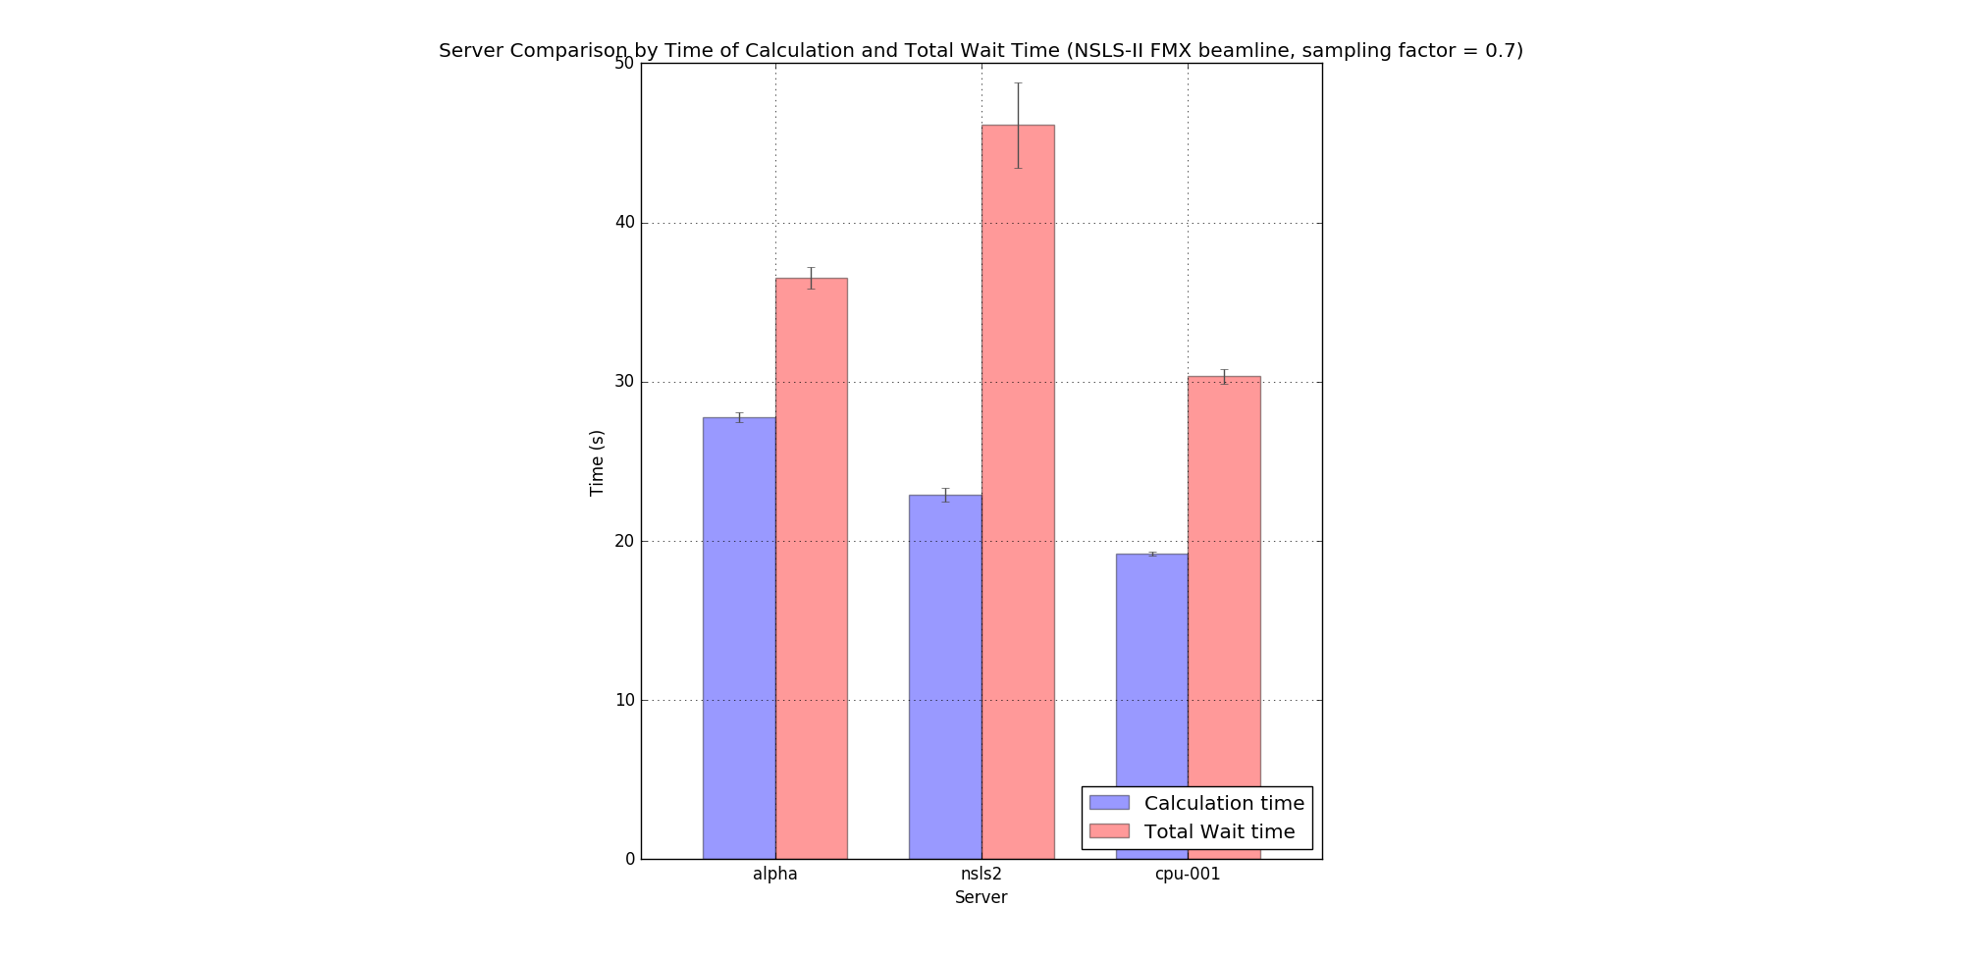

Finally, to assess the impact of server preparation time on total wait time, tests were also performed on the web interface to figure out how much time was spent by the server on various pre-calculation preparations, such as creating folders for the simulation results to be saved to. This was done by subtracting the time of calculation from the total server time. The plot below illustrates the results, time in seconds.

